Assignment 6: Functional Dependencies of Primary Keys

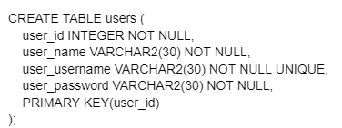

**user**(user_id, user_name, user_username, user_passsword)

FD of user_id = {

user_id → user_name,

user_id → user_username,

user_id → user_password

}

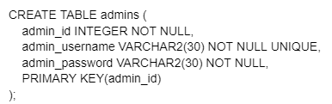

**admins**(admin_id, admin_username, admin_password)

FD of admin_id = {

admin_id → admin_username,

admin_id → admin_password

}

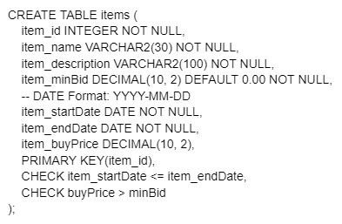

**items**(item_id, item_name, item_description, item_minBid, item_startDate, item_endDate, item_buyPrice)

FD of item_id = {

item_id → item_name,

item_id → item_description,

item_id → item_minBid,

item_id → item_buyPrice,

item_id → item_startDate,

item_id → item_endDate

}

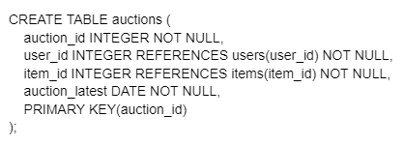

**auctions**(auction_id, user_id, item_id, auction_latest)

FD of auction_id = {

auction_id → auction_latest

}

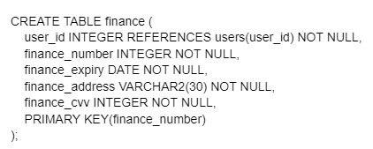

**finance**(finance_number, user_id finance_expiry, finance_address, finance_cvv)

FD of finance_number = {

finance_number → finance_expiry,

finance_number → finance_address,

finance_number → finance_cvv

}

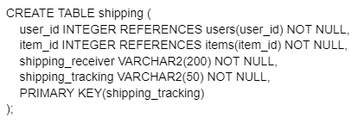

**shipping**(user_id, shipping_receiver, shipping_tracking)

FD of shipping_tracking = {

shipping_tracking → shipping_receiver

}

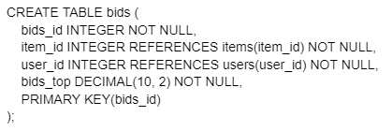

**bids**(bid_id, item_id, user_id, bids_top)

FD of bid_id = {

bids_id → bids_top

}

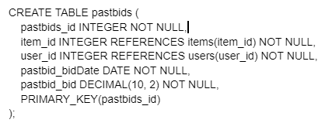

**pastbids**(pastbids_id, item_id, user_id, pastbid_bidDate, pastbid_bid)

FD of pastbids_id = {

pastbids_id → pastbid_bidDate,

pastbids_id → pastbid_bid,

}

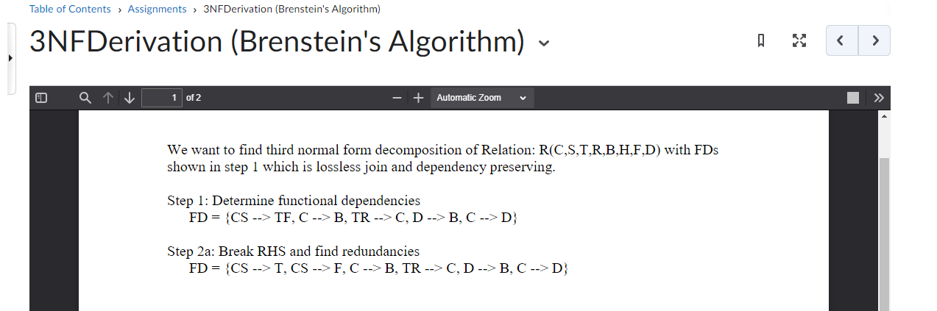

*Referencing this document for the set notation format*